Worksheet Revision : |  |  |  |  | Serial No.:
Customer: |  |  |  | Completed by/Date:
Project: |  |  |  | Reviewed by/Date:
SOR No.: |  | Quote No. |  | System Item No.:

Mains Power : 85 to 264V AC (47 to 440Hz) <and> 110 to 264V DC Optional Low Voltage DC (18 to 36V )
Head Pairs and Mounting Hardware ( all sizes in mm )
N1 N2 N3 N4
Nominal Head Pair Sizes: should be 50mm larger than bus bar to accommodate mounting hardware
Mounting Channels: 2 pieces provided with each head pair ( standard : N# mm + 165mm )
Head Clamp Threaded Rods: 4 pieces provided with each system ( standard : 105mm )
Bus Clamp Threaded Rods: 2 pieces provided with each head pair ( standard : N# mm + 70mm )
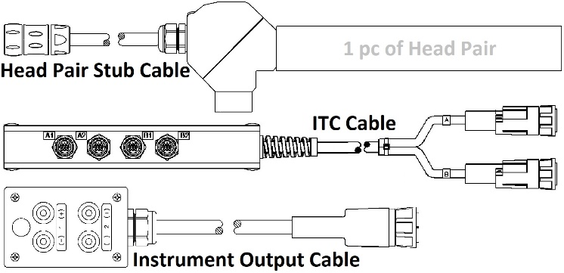
|---0.25%----| |---0.75%---|
|---------0.50%--------| Head Pair Combination
|--- 0.50% --| measurement accuracies
Cable Lengths Standard Custom
Head Pair Cable Stubs 2m m
ITC Cable 5m m
Instrument Output Cable 2.5m m
Process Output Cable 10m m
Mains Power Cable 10m m
LVDC Mains Power Adapter 2m m
Carry / Transport Cases Hard Side ( <3 head pairs & Meter Unit) Soft Side (ITC, output & mains cables)

Main / Std. Outputs |  |  |  |  |  |  |  |  |  |  |  | 0% F.S. | Cal.Pt. kA  Std. Cal. Pt. is + 100% of F.S.
 |  |  |  |  | Main Measuring Range→ |  |  |  | - 100% F.S. - kA |  |  | 0kA | + 100% F.S. + kA
Output Type  Choose One | Current 1 |  |  |  | “0 to 20 mA” |  |  |  | -20mA |  |  | 0mA | +20mA
 | Current 2 |  |  |  | “4 to 20 mA” |  |  |  | -12mA |  |  | +4mA | +20mA
 | Current 3 |  |  |  | “4 to 20 mA” |  |  |  | +4mA |  |  | +12mA | +20mA
 | Voltage 1 |  |  |  | “0 to 1 Volt” |  |  |  | -1 Volt |  |  | 0 Volts | +1 Volt
 | Voltage 2 |  |  |  | “0 to 10 Volts” |  |  |  | -10 Volts |  |  | 0 Volts | +10 Volts
Trip Setpoint 1: |  | kA |  |  |  | Forward | Reverse |  |  | Not Used |  | trip must be within +/-5% to +/-100% of Main F.S..
Optional“PE”Outputs  ( Protection Extension )  None |  |  |  |  |  |  |  |  |  |  | (“-“ not used for Sigma) | 0% F.S. | Cal.Pt. kA  Std. Cal. Pt. is + 100% of F.S.
 |  |  |  |  | PE Measuring Range→ |  |  |  |  |  | -100% F.S. - kA | 0kA | +100% F.S. + kA
Output Type  Choose One | Current 1 |  |  |  | “0 to 20 mA” |  |  |  |  |  | -20mA | 0mA | +20mA
 | Current 2 |  |  |  | “4 to 20 mA” |  |  |  |  |  | -12mA | +4mA | +20mA
 | Current 3 |  |  |  | “4 to 20 mA” |  |  |  |  |  | +4mA | +12mA | +20mA
 | Voltage 1 |  |  |  | “0 to 1 Volt” |  |  |  |  |  | -1 Volt | 0 Volts | +1 Volt
 | Voltage 2 |  |  |  | “0 to 10 Volts” |  |  |  |  |  | -10 Volts | 0 Volts | +10 Volts
Trip Setpoint 2: |  | kA |  |  |  | Forward |  | Reverse |  |  | Not Used | trip must be within +/-5% to +/-100% of PE F.S.  trip must be within +/-5% to +/-100% of PE F.S.
Trip Setpoint 3: |  | kA |  |  |  | Forward |  | Reverse |  |  | Not Used
Optional Display : None |  |  |  |  |  | DC (DC Applications) |  |  |  |  | True RMS (AC or Pulse Applications)
Special Instructions on 2nd page
ALL COMMENTS, CORRECTIONS AND/OR CHANGES MUST BE INITIALED AND DATED

Serial No.:
Special Instructions :
NOTE : All Comments, Corrections and/or Changes Must be Initialed and Dated

